SQT TOOL

**Programming with Python**

**BYGB 799O-004**

Instructed by Han Xu

Yucheng Zhang

Qilin Liu

Hengda Shen

Lu Chen

12/10/2019

FALL 2019

**Student Query Tool (SQT)**

SQT is a Python program to read student records from a file and let the user enter queries

in order to see a detail or summary report.

**Installation**

Please install a Python 3.7 or an Integrated Development Environment (Pycharm, Jupyter) to open it.

**Usage**

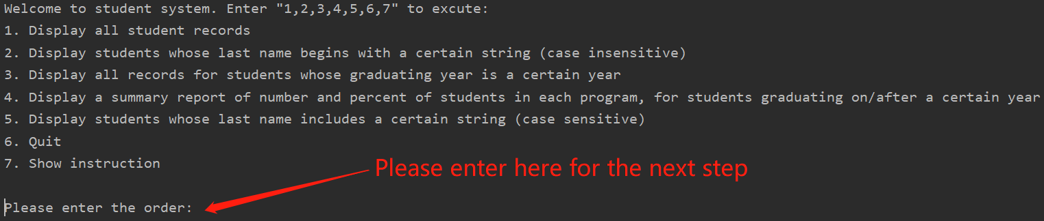

7 selections are available:

1. enter 1, the SQT will show all student records

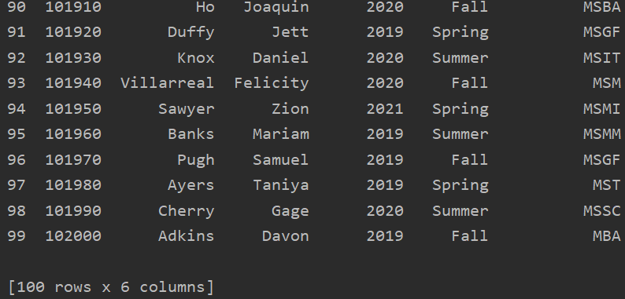

1. enter 2, the SQT will execute the next step of displaying students whose last name begins with a certain string (just need the initial of the last name, no difference between the upper or lower case), please enter the character



( c is not capital, but still show the name start with Cr)

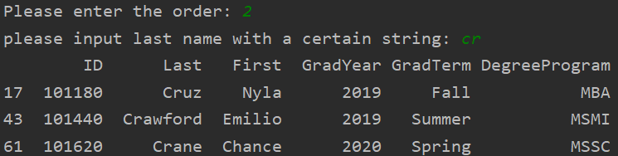

1. enter 3, the SQT will execute the next step of displaying all records for students whose graduating year is a certain year, please enter the number of the year



1. enter 4, the SQT will execute the next step of displaying a summary report of number and percent of students in each program, for students graduating on/after a certain year, please enter the number of the year.



After getting the result, we set **an extra function**: to get the pie chart of the percentage.

the SQT will ask to draw the piechart or not, y (or Y) for yes and n (or N) for no



if yes, there is a window ejected to show the result with program name, corresponding percentage, and title for input year

(here is an example for 2020 graduates)

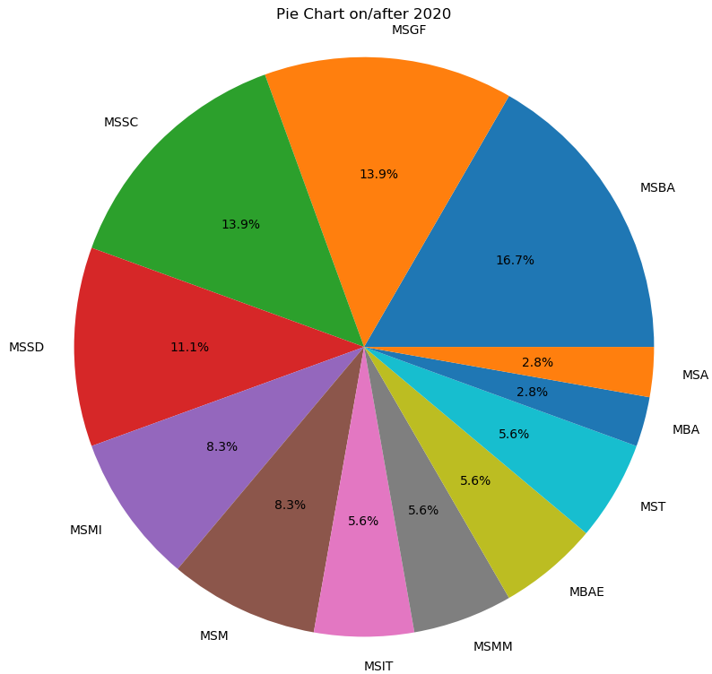

1. enter 5, there is another extra function: SQT will display students if its last name includes the input, this is case sensitive, please enter the character you want.

(here is an example for students whose name include “b”)

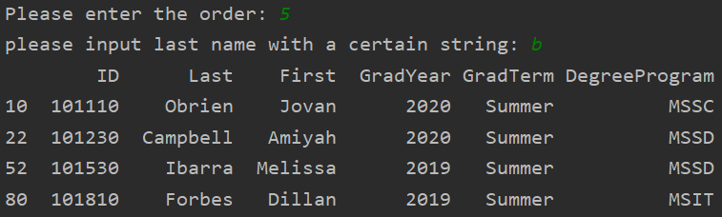

1. enter 6, the SQT will execute the quit order, the SQT will stop
2. enter 7, you can see the whole menu again for instructions



**Authors and acknowledgment (order by the last name)**

Lu Chen

Qilin Liu

Hengda Shen

Yucheng Zhang

**License**

Fordham University